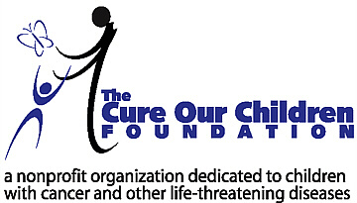

For Immediate Release:

New Research Uncovers “Donated Sick Leave” as a No-Cost Method
for Employers to Help Families in Need

LOS ANGELES, Calif. – July 19, 2005 – The Cure Our Children Foundation, a nonprofit charitable foundation dedicated to children, announced today the availability of its research entitled “A Parent's Dilemma: My Paycheck or My Sick Child?” indicating that for little or no cost to private employers, an excellent employee benefit may be given to those parents that have children with cancer or other life-threatening diseases. As a result of these findings, The Cure Our Children Foundation also announced today the availability of a National Model Donated Sick Leave Program designed to assist parents and caregivers of children undergoing treatment for cancer and other life-threatening diseases.

Donated Sick Leave Programs permit employees of a company to donate one or more days of sick leave or vacation time to a fellow employee who must take off extended time to care for an ill child or family member. Employers then transfer the paid time to the affected employee so the employee may be paid during time taken off work caring for their ill child; all with little or no cost to their employer. Working together with a California Employment Attorney, the foundation has developed a National Model Donated Sick Leave Program along with all the forms needed to easily allow widespread adoption of the program by private industry.

Key elements of the research include:

- Complete and easy-to-understand forms and instructions on how to start a Donated Sick Leave Program at your workplace.
- A thorough explanation and discussion of the benefits of a Donated Sick Leave Program both for employees and employers.
- An overview and comparison of the few existing Donated Sick Leave Programs available at select universities and government agencies.
- Names, phone numbers, references, and Web links to sources of information about existing Donated Sick Leave Programs and their human resources officials.

The foundation research is available at no cost at: http://www.cureourchildren.org/donatedleave.htm

The Cure Our Children Foundation identifies important under-researched children's issues and devotes extensive resources to educate and guide parents, professionals, government and the public. The foundation receives thousands of website visits every month. The results of the research are provided as a free public service, and are supported by donations to the foundation. The foundation has a number of other research projects underway that will benefit families.

Contact: Barry Sugarman, B.S.ENGR., President, The Cure Our Children Foundation, mailto:barry@cureourchildren.org , Phone: 310-355-6046, Fax: 310-454-9592, http://www.cureourchildren.org

