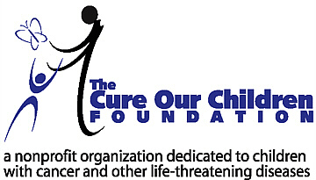

For Immediate Release:

New Research Clears up the Controversy
over the Role of Nutrition and Dietary Supplements in Cancer

LOS ANGELES, Calif. – May 4, 2004 – The Cure Our Children Foundation, a nonprofit foundation dedicated to children, announced today the publication of its extensive research clearing up the role of nutrition and dietary supplements for those undergoing treatment for cancer. The foundation concluded that as long as the role of nutrition and dietary supplements is complementary to the medical treatment of cancer, and well designed, the overall benefits are clear.

Cancer and nutrition experts interviewed for this research project stated that when designed and used appropriately, nutrition and dietary supplement programs can help maintain strong blood and immune systems, keep electrolytes in balance, lessen nausea, improve appetite and digestion, and generally give the cancer patient more energy so they feel better.

Key elements of the research include:

- Complete instructions on basic nutrition, and its application to the cancer patient.
- An extensive overview and explanation of the numerous dietary supplement categories and ingredients which are useful for cancer patients.
- A listing of the recognized organizations that train and certify individuals to qualify them to provide nutrition and dietary supplement programs.
- Names, phone numbers, and web links of sources of nutritional and supplement products and information, along with lists of organizations that can also assist.
- Easy-to-understand guidance on how to design and apply a nutrition and dietary supplement program for the cancer patient, or a healthcare professional.

The foundation research is available for free at: http://www.cureourchildren.org/nutrition.htm

The Cure Our Children Foundation identifies important under-researched children's issues and devotes extensive resources to explain and guide parents, professionals, government and the public. The results of the research are provided for free as a public service. Research is supported by donations to the foundation. The foundation has a number of other exciting research projects in the planning stages. The foundation receives thousands of website visits every month.

Contact: Barry Sugarman, B.S.ENGR., President, The Cure Our Children Foundation, mailto:barry@cureourchildren.org , Phone 310-355-6046, Fax 310-454-9592, http://www.cureourchildren.org

