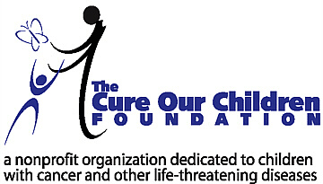

For Immediate Release:

Ground Breaking Research Reveals Answers to Important
Side-Effect Issues in Pediatric and Adult Cancer Treatment

LOS ANGELES, Calif. – May 12, 2003 – The Cure Our Children Foundation, a nonprofit foundation dedicated to children with cancer and other life-threatening diseases, announced today the publication of its original research into mouthsores caused by cancer treatments. This common side effect is often a source of pain and infection, treatment delays, and other problems that interfere with recovery.

Research conducted by the foundation revealed a wide variety of preventative, hygienic, and therapeutic treatment methods in both traditional and natural approaches that may be used to alleviate this condition. In addition to extensive worldwide research, interviews were conducted with prominent oncologists, nurses, natural health care practitioners, compounding pharmacists and other health care professionals; all of whom contributed to this significant research project.

The foundation research is available for free at:
http://www.cureourchildren.org/mouthsores.htm

The Cure Our Children Foundation identifies important under-researched cancer issues and devotes extensive resources to determine all available treatment and care options, and any investigational treatments that are ongoing. The results of the research are provided free to the public as a service to cancer patients and families affected by cancer. Research is supported by donations to the foundation. The foundation has a number of other exciting research projects in the planning stages. The foundation receives thousands of web site visits every month from parents of children with cancer, and both children and adult patients.

Contact:
Barry Sugarman, B.S.ENGR., President
The Cure Our Children Foundation
barry@cureourchildren.org
Phone 310-355-6046, Fax 310-454-9592

